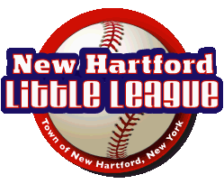
President Commissioner
Salvatore Paladino Ben Perra
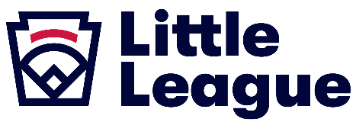
Vice President Secretary Lisa Calli Bob Calli

Treasurer Player Agent
Peter Logue Brian Bansner

“Little League believes in the power of youth baseball and softball to teach life lessons that build stronger individuals and communities.”
November 6, 2025

Dear Prospective Supporter:

Your sponsorship of New Hartford Little League benefits over 350 boys and girls, their families, 70+ volunteers, 30 teams, and the entire community. Thank you! We are proud of our players and the New Hartford Little League’s long tradition of excellence. The upcoming season is sure to be exciting, competitive, and fun. We ask that you…

Please support the 2026 New Hartford Little League season!
On the back of this letter, please find the 2026 NHLL SPONSORSHIP AGREEMENT. If you would like to be a sponsor, please indicate your level of support, and send a copy of the agreement along with a check by March 5, 2026.

2026 Sponsorship Levels
Your donation supports NHLL’s annual operations and capital projects…THANK YOU!
Single ($250): Logo goes on a large sponsorship banner (with other single-level sponsors) on the first base dugout, a very conspicuous location.
Double ($450): Sponsor is given their own outfield fence sign (Limited Space Available)
Triple ($700): T-Ball or Minor League Team Sponsorship (Limited Availability), and Dedicated Outfield Fence Sponsor Sign
Home Run ($825): Game Day Recognition over NHLL Field P.A. System, T-Ball or Minor League Team Sponsorship, and Outfield Sponsor Sign
Grand Slam ($1000): Rotating Logo on NHLL Livestream feed, Logo goes on NHLL website main page, 2026 Hall of Fame Plaque at Concession Stand, Logo goes on NHLL Championship Banner, Game Day Recognition on NHLL P.A. System, T-Ball or Minor League Team Sponsorship, and Outfield Sponsor Sign.
Please contact me if I can answer any questions. We again thank you for your support. Playball!
Sincerely,

Salvatore Paladino
President, New Hartford Little League
(315) 240-7580 |sal.paladino@gmail.com

2026 NHLL SPONSORSHIP AGREEMENT

This agreement is by and between NHLL and the sponsor.

NHLL, Inc and the Sponsor agree as follows:

- In consideration of the sum noted below to be paid by the Sponsor, NHLL agrees to recognize Sponsor at the designated level.
- The Sponsor agrees that it will not use the NHLL name nor solicit contributions in its name without the express written consent of NHLL.
- Payment of the consideration set forth above concludes any and all obligations on the part of the Sponsor.
- This agreement may not be modified unless, in writing, signed by both parties. Further, this agreement supersedes any and all prior and/or contemporaneous verbal or written agreements.

Single($250): ___ Double($450): ___ Triple($700): ___ Home Run($825): ___Grand Slam ($1000)___

____________________________________________________________
Sponsor Organization

____________________________________________________________
Sponsor Agent (Printed)

____________________________________________________________
Sponsor Agent (Authorized Signature)

Does sponsor have children playing in the league? Yes ___No___
If yes, names and ages: _________________________________________
We will do our best to ensure sponsor children are playing on sponsor’s team. We cannot guarantee it.

Date: _____________________

Email and Phone: _____________________________________________

Please sign, enclose a check, and return to:
New Hartford Little League
PO Box 202
New Hartford NY, 13413
Please make Checks Payable to: NHLL
Special Requests:

______________________________________________________________________________

______________________________________________________________________________

The NHLL Board will contact you to confirm your logo and other items only if needed. Unless otherwise instructed, the logo from last year will be used this year.
THANK YOU!

